**Computer**

**Network**

**Class Six**

**Lab 1**

|  |
| --- |
| Lab Objectives:  * Computer network * Client, Server, Media |

# Network

## Networks are everywhere—or so it seems. You can hardly do anything with data that does not involve a network.

## In this course, you’ll begin by relating networks to situations and concepts you already know. Once you have a basic understanding of what networks are and what they can do, it helps if you can actually begin working with them

# Human Networks

## A network consists of two or more entities, or objects, sharing resources and information. Although this course is about computer networks, but there are networks that don’t involve computers, and those networks are everywhere. In a family

## ফেব্রুয়ারী 15

father, mother and all of their child's are connected with each other. We can call it a family network.

# Peer Network

## Outside the family, there is a community that offers a wider array of re-sources than the typical family can provide. Naturally,a family is connected to many other outer resources to fulfill their needs or demands. Like in a **family** father is involved with **work**, children are going to **school**, mother goes **store / shop** for their daily shopping. In the holiday the family go to **restaurant** for refreshment.

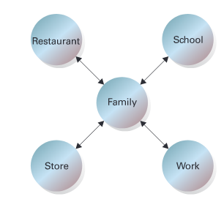

## This is a peer network, each network is connected with another network.

# Restaurant Network: The Client and the Server

## For instance, when you go to dinner at a restaurant, you be-come a customer, or client, enjoying the food and drink prepared and served to you by the restaurant.

## On the other hand, the waiter works as a server,controlling and providing his customers with access to resources in the form of placing orders for and delivering food items.

## The server knows that re-quests will be made of him so he needs to prepare entree (main dish) so that he can provide that to waiter and waiter can serve to the customer.

## ফেব্রুয়ারী 15 _2

## 

## So there may be a single network like family where many attributes (father, mother, sister, brother etc) are connected to each other

## There may be a peer network, where a network is connected with another network

## Also there could be a client and server network where server provides something and client get that by the help of media.

In computer Network the networking concepts and procedures are absolutely same as before.

# Getting Started

## A computer network is a system in which multiple computers are connected to each other to share information and resources.

## In order for two computers to talk to each other they need:

## To be Connected (cable or Wireless) this is known as the connection media.

## To have a common language. in Networking this is known as a protocol.

## To have An Address.

# Characteristics of a Computer Network

## IMG_256Share resources from one computer to another.

## Create files and store them in one computer, access those files from the other computer(s) connected over the network.

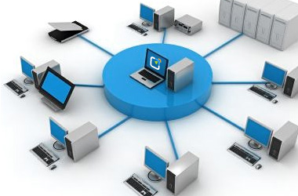

## Connect a printer, scanner, or a fax machine to one computer within the network and let other computers of the network use the machines available over the network.

